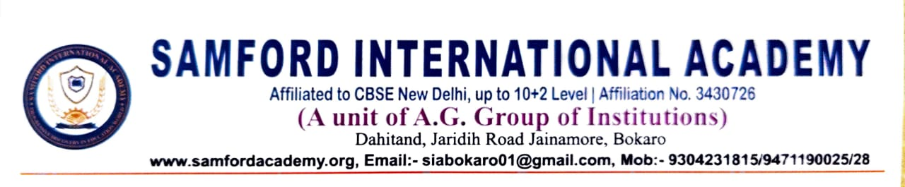

Following Dates are finalized for remaining subjects of CBSE Class XII (SSCE)
Practical Examination 2025-26 :

1)Economics – 20.01.2026
2)Painting – 04.02.2026

Yours sincerely,
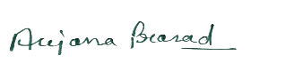
Mrs Anjana Prasad
Principal
Samford International Academy

